**Advanced MIS Programming 3363 Spring 2016 Mid-Term Exam Hands-On**

Due Date: Friday, March 25th, 2016 @ Midnight

80 Total Points

**Instructions**: For this portion of the exam you will be working on developing a website with the following requirements. You may use any resources that you have available or find (e.g., book, slides, videos, examples, google, etc.), however it MUST be completed individually. You should not work in groups or ask other students in the class for help on specific aspects of the exam. I will be available to answer simple questions or direct you to potential resources we have used in class that you can use for an idea.

**Section 1: Website Creation and Layout (30 points)**

1. Create a new website with a layout matching the following sketch without using a template:
   1. 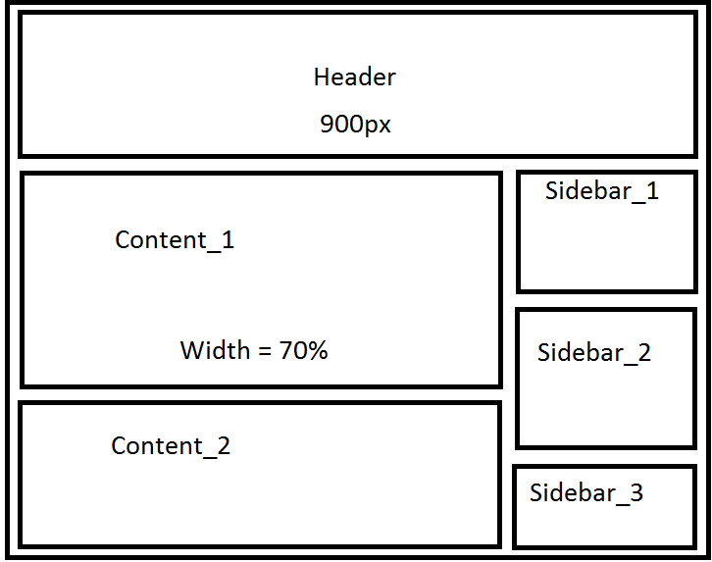
2. Create two child/content pages using the MasterPage
   1. A homepage which will be the starting point for the website
   2. A “thank you” page which will be used in the application requirements.
3. Give the website a color scheme using the following colors
   1. 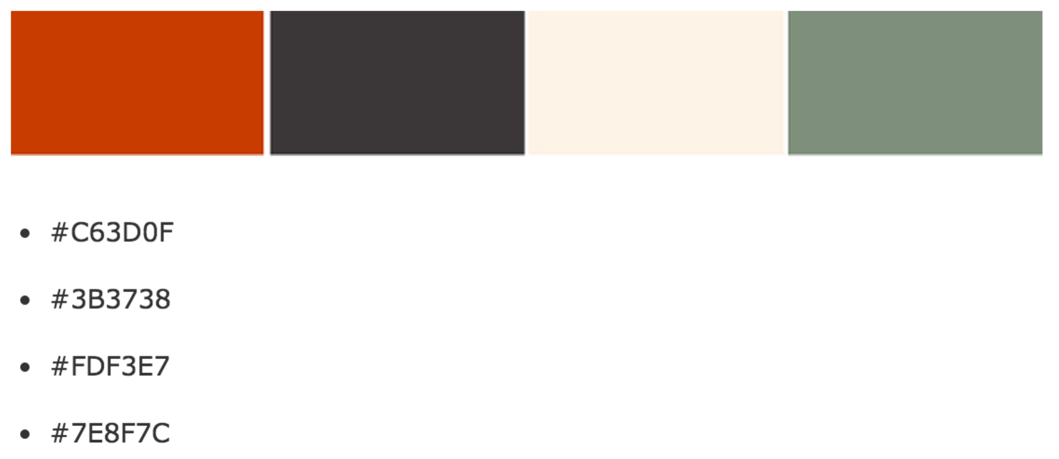

**Section 2: Content Development (30 points)**

1. In the top “header” of the page, enter your name and email address in large letters.
2. In each of the three boxes to the right side of the page, place a picture of your choice using ASP.NET tools. Make sure that they fit in the boxes.
3. In the first box on the left side after the header add a short paragraph about what aspects of web development you would LIKE to learn about.
   1. Set custom font type, size, and color
4. In the second box on the left side after the header add ASP.NET tools that will do the following:
   1. Capture a users Name, Email Address, and determine if they are a Student or Faculty Member.
      1. Add validators on each of the inputs to ensure that they are all entered and validated correctly.
   2. Allow users to “submit” this information and send it to the “thank you” page where it displays the information that the users submitted.

**Section 3: AJAX development (20 points)**

1. On the “thank you” page, add in an update panel that rotates through the same three pictures that were listed on the Homepage. (Hint: think about the image rotator we made in class)

**Submitting the assignment**: When you are finished with your website, make sure to zip up the entire folder, double check that the file is indeed correct and not only the solution file, and upload the assignment to the dropbox link on D2L.